 [Translated from Chinese (Simplified) to English - www.onlinedoctranslator.com](https://www.onlinedoctranslator.com/en/?utm_source=onlinedoctranslator&utm_medium=docx&utm_campaign=attribution)

**Table of contents**

one,Product Introduction 2

1.1 Overview 2

1.2 Features 3

1.3 Application Areas 3

two,Electrical, Mechanical and Environmental Specifications 3

2.1 Electrical specifications 3

2.2 Operating environment and parameters 3

2.3 Mechanical installation diagram 4

2.4 Enhanced heat dissipation 4

three,Driver interface and wiring introduction 5

3.1 Interface Description 5

3.1.1 Control signal interface 5

3.1.2 Strong power interface 5

3.2 Control signal interface diagram 6

3.3 Control signal logic control function 6

3.4 Built-in acceleration function 7

3.5 Built-in deceleration function 7

3.6 Indicator Status 7

3.7 Wiring requirements 7

Four,DIP switch function setting 8

4.1 Current Setting 8

4.2 Quiescent Current Setting 8

4.3 Speed ​​range setting 8

five,Power supply selection 8

six,Protection function 9

6.1 Overvoltage Protection 9

6.2 Undervoltage protection 9

6.3 Phase loss protection 9

**DM456-V-24 digital two-phase stepper driver**

# **Product Introduction**

## **1.1 Overview**

DM456-V-24 is an analog speed control product launched by Gerui IoT Technology Co., Ltd. It can connect two motors at the same time to achieve synchronous speed control. Its external 24V start and direction signals control the start and reverse of the motor. The motor speed is adjusted by an external 10K potentiometer, and the maximum speed is set by the dial selection.

DM456-V-24 driver adopts servo-like control principle, integrating vector control technology, built-in micro-segmentation technology and adaptive filtering technology, which greatly optimizes the performance of stepper motors. It runs smoothly at low, medium and high speeds with low noise. Accurate and smooth pure sinusoidal current vector control technology effectively reduces motor heating. It has a very high cost-effectiveness and can meet the application needs of most occasions.

The normal driving voltage range of the DM456-V-24 driver is DC24~50V, and it is suitable for two-phase hybrid stepper motors with a peak current below 5.6A and an outer diameter of 42~86mm.

## **1.2 Features**

●New 32-bit DSP technology●Easy to install

●Can drive 4, 6, 8-wire two-phase stepper motor Optically isolated differential signal input

●Built-in micro-segmentation ●Pulse response frequency up to 200KHz (higher frequency can be adjusted)

●Precise current control greatly reduces motor heating ●Low vibration and low noise

●The current automatically reduces to half when stationary ●With overvoltage, undervoltage, phase loss and other protection functions

## **1.3 Application Areas**

Suitable for various small and medium-sized automation equipment and instruments, such as: engraving machines, marking machines, cutting machines, plotters, CNC machine tools, automatic assembly equipment, etc. It has a particularly good application effect in equipment applications where users expect low noise and high speed.

# **Electrical, Mechanical and Environmental Specifications**

## **2.1 Electrical specifications**

|  |  |  |  |  |
| --- | --- | --- | --- | --- |
| **illustrate** | **DM456-V-24** | | | |
| **Minimum** | **Typical Value** | **Maximum** | **unit** |
| **Output Current** | 1.0 | - | 5.6 | A |
| **Input power voltage** | twenty four | 36 | 50 | VDC |
| **Control signal input current** | 7 | 10 | 16 | mA |
| **Step pulse frequency** | 0 | - | 200 | KHz |
| **Insulation resistance** | 50 |  |  | MΩ |

## **2.2 Operating environment and parameters**

|  |  |  |
| --- | --- | --- |
| **Cooling method** | | Natural cooling, fan cooling |
| **Usage Environment** | **occasion** | Do not place it near other heating equipment. Avoid dust, oil mist, corrosive gas, high humidity and strong vibration. Flammable gas and conductive dust are prohibited. |
| **temperature** | 0——50℃ |
| **humidity** | 40-90%RH |
| **vibration** | 10~55Hz/0.15mm |
| **Storage temperature** | | -20℃~65℃ |

## **2.3 Mechanical installation diagram**

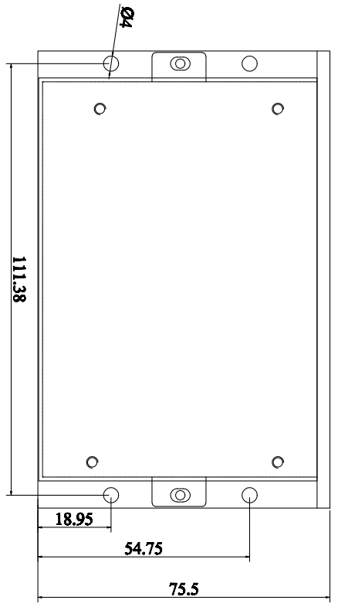 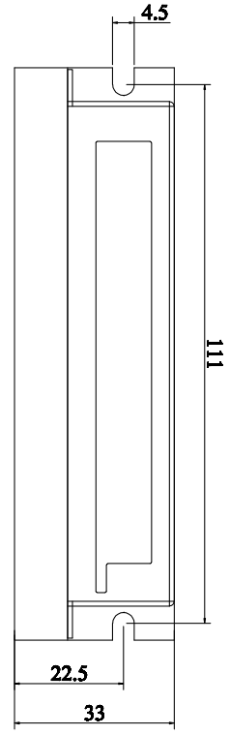

Front installation diagram Side installation diagram

Figure 1 Installation dimensions (unit: mm)

**※Side installation is recommended for better heat dissipation. When designing the installation dimensions, pay attention to the terminal size and wiring!**

## **2.4 Enhanced heat dissipation**

1. The reliable operating temperature of the driver is usually within 50℃, and the operating temperature of the motor is within 80℃;
2. It is recommended to select the automatic half-current mode when using, that is, when the motor stops, the current is automatically reduced by half to reduce the heating of the motor and driver;
3. When installing the driver, please install it sideways and allow strong air convection to form on the bottom of the driver. If necessary, install a fan near the driver inside the machine to form air convection to assist in heat dissipation and ensure that the driver operates within a reliable operating temperature range.

# **Driver interface and wiring introduction**

## **3.1 Interface Description**

### **3.1.1Control signal interface**

|  |  |  |
| --- | --- | --- |
| **name** | **Function** | **illustrate** |
| OPTO | Control signal (ENA, DIR) common terminal | Connect to +24V signal |
| DIR- | Direction signal input negative terminal | When ENA- is valid and DIR- is also valid,Motor reverse |
| ENA- | Start signal input negative terminal | When ENA- is valid,Motor start-up |
| +3.3V | Connect potentiometer A**(Note)**port | The wiring of the A and C ends of the potentiometer are interchangeable, and specific customers can make wiring according to actual on-site applications. |
| AIN | Connect potentiometer B**(Note)**interface |
| GND | Connect potentiometer C**(Note)**interface |

**Note: The potentiometer interface diagram is as follows:**

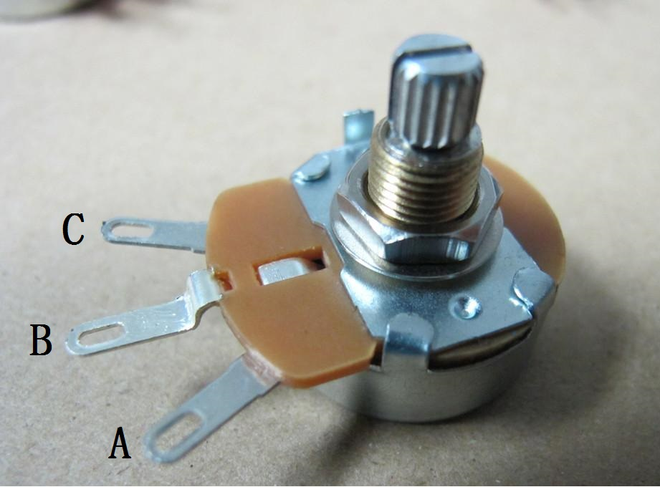

### **3.1.2Strong power interface**

|  |  |  |
| --- | --- | --- |
| **name** | **Function** | **illustrate** |
| GND | DC power supply negative terminal | DC24~50V, recommended +24V, +36V |
| +VDC | DC power supply positive terminal |
| A+、A- | Motor A phase output terminal | Connect the motor A phase coil, pay attention to the phase sequence |
| B+, B- | Motor B phase output terminal | Connect the motor B phase coil, pay attention to the phase sequence |

## **3.2 Control signal interface diagram**

The control signal end of the DM456-V-24 driver adopts a common anode interface with a built-in photocoupler, which has strong anti-interference ability in harsh environments. The interface circuit diagram is shown below.

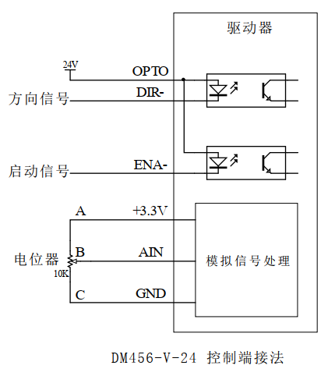

Figure 2 Schematic diagram of control end interface circuit

▶Note:

1. **The signal end of DM456-V-24 is 24V controlled, so if 5V signal control is required, you need to contact our company to make changes!**
2. **If you short-circuit the +3.3V port and the AIN port directly, the motor will run at the maximum speed corresponding to the current dial after starting!**

## **3.3 Control signal logic control function**

The DM456-V-24 driver can run with only one motor or two motors at the same time. Its external +24V, ENA- and DIR- signals control the start and reverse of the motor. The motor speed is adjusted by an external 10K potentiometer, and the maximum speed is set by the dial selection.

When the ENA-terminal signal is valid (ENA- is low level), the driver generates pulses automatically and the motor starts running; when the DIR-terminal signal is valid (DIR- is low level), the motor runs in reverse; when the ENA-terminal signal is invalid (ENA- is high level), the motor stops running. The control logic of the motor rotation direction is as follows.

|  |  |  |
| --- | --- | --- |
| **DIR signal** | **ENA signal** | **Direction of rotation** |
| invalid | invalid | stop |
| invalid | efficient | Positive direction |
| efficient | invalid | stop |
| efficient | efficient | Reverse direction |

▶Note: The rotation direction shown in the above table is for reference only. The actual rotation direction is related to the wiring method of the motor. Customers can adjust it according to the actual situation on site.

The motor running speed is adjusted by an external 10K potentiometer, and the maximum running speed is set by the dial selection.

## **3.4 Built-in acceleration function**

All speed gears have built-in acceleration, and the acceleration time is about 1000ms. If the customer wants to set the acceleration time by himself, it can be set through the PC software.

## **3.5 Built-in deceleration function**

All speed gears have built-in acceleration, and the deceleration time is about 200ms. If the customer wants to set the deceleration time by himself, it can be set through the PC software.

## **3.6 Indicator Status**

The green LED is the power indicator light. When the driver is powered on, the LED is always on; when the driver is powered off, the LED is off.

The red LED is a fault indicator. When a fault occurs, the indicator flashes in a cycle of 3 seconds. When the fault is eliminated by the user, the red LED goes out. The number of times the red LED flashes in 3 seconds represents different fault information. The specific relationship is shown in the following table:

|  |  |  |  |
| --- | --- | --- | --- |
| **Serial number** | **Number of flashes** | **Red LED flashing waveform** | **Fault Description** |
| 1 | 2 | 07aaeaeba1020372a59a448bd381b86 | Overvoltage fault (voltage>DC50V) |
| 2 | 3 | 6ba76b7c1245b14a916aadd4c40f2f2 | Undervoltage fault (voltage <DC20V) |
| 3 | 5 | 6f084afacbf711a593eea399b047aa1 | Motor open circuit (phase loss) |

## **3.7 Wiring requirements**

1. In order to prevent the driver from being interfered, it is recommended that the control signal use shielded cable, and the shield layer is short-circuited with the ground wire. Except for special requirements, the shield line of the control signal cable is grounded at one end: the host computer end of the shield line is grounded, and the driver end of the shield line is suspended. Only the same point is allowed to be grounded in the same machine. If it is not a real ground wire, there may be serious interference. In this case, the shield layer is not connected.
2. The pulse and direction signal lines are not allowed to be wrapped side by side with the motor lines. It is best to separate them by at least 10 cm. Otherwise, the motor noise will easily interfere with the pulse direction signals and cause inaccurate motor positioning, system instability and other faults.
3. If one power supply supplies multiple drives, they should be connected in parallel at the power supply. Chain connection from one drive to another is not allowed.
4. It is strictly forbidden to plug or unplug the high-voltage terminals of the driver while it is powered on. When the motor is stopped, there is still a large current flowing through the coil. Plugging or unplugging the terminals while it is powered on will cause a huge instantaneous induced electromotive force that will burn out the driver.
5. It is strictly forbidden to connect the wire end to the terminal after tinning it, otherwise the contact resistance may increase and the terminal may be damaged by overheating.
6. The wiring ends must not be exposed outside the terminals to prevent accidental short circuits and damage to the driver.

# **DIP switch function setting**

The DM456-V-24 driver uses a 6-position dip switch, SW1-SW3 is used to set the current, and SW4-SW6 is used to set the maximum speed. The detailed description is as follows:

|  |  |  |  |  |  |
| --- | --- | --- | --- | --- | --- |
| **SW1** | **SW2** | **SW3** | **SW4** | **SW5** | **SW6** |
| Current setting | | | Speed ​​range setting | | |

## **4.1 Current Setting**

|  |  |  |  |  |  |
| --- | --- | --- | --- | --- | --- |
| **Output peak current(A)** | **Output effective current (A)** | **SW1** | **SW2** | **SW3** | **Current self-setting** |
| 1.0 | 0.7 | on | on | on | When SW1, SW2, and SW3 are all off, the required effective current value can be set through the PC software. The maximum value is 6000mA and the resolution is 1mA. |
| 1.4 | 1.0 | off | on | on |
| 2.1 | 1.5 | on | off | on |
| 2.8 | 2.0 | off | off | on |
| 3.8 | 2.5 | on | on | off |
| 4.2 | 3.0 | off | on | off |
| 4.9 | 3.5 | on | off | off |
| 5.6 | 4.0 | off | off | off |

## **4.2 Quiescent Current Setting**

The driver is set to half-current lock by default. When the motor stops, the current is automatically reduced to half. If full-current lock is required, the user can adjust the lock current percentage through the PC software.

## **4.3 Speed ​​range setting**

|  |  |  |  |  |
| --- | --- | --- | --- | --- |
| **R/min** | **SW4** | **SW5** | **SW6** | **Segment Description** |
| 0-100 | on | on | on | When SW4-SW6 are all in the off state, the user can set the maximum operating speed of the analog speed regulation through the PC software, the unit is r/min, and the resolution is 1. |
| 0-150 | off | on | on |
| 0-200 | on | off | on |
| 0-250 | off | off | on |
| 0-300 | on | on | off |
| 0-350 | off | on | off |
| 0-400 | on | off | off |
| 0-450 | off | off | off |

# **Power supply selection**

The power supply voltage can work normally within the specified range. The DM456-V-24 driver is best powered by a regulated DC switching power supply. It should be noted that the output current range of the switching power supply must be set to the maximum. An unregulated DC power supply can also be used, but it should be noted that the peak value of the rectified voltage ripple should not exceed the specified maximum voltage. It is recommended that users use a DC voltage lower than the maximum voltage to avoid grid fluctuations exceeding the driver voltage operating range.

▶Note:

1. When wiring, pay attention to the positive and negative poles of the power supply and do not connect them in reverse;
2. When wiring, pay attention to the position of the power interface and do not connect it to the motor port. After connecting, it is best to confirm whether it is connected correctly;
3. It is best to use a regulated DC switching power supply;
4. When using an unregulated DC power supply, the power supply current output capacity should be greater than 60% of the driver set current;
5. When using a regulated DC switching power supply, the output current of the power supply should be greater than or equal to the operating current of the driver;
6. To reduce costs, two or three drivers can share one power supply, but the power supply must be large enough.

# **Protection function**

## **6.1 Overvoltage Protection**

When the input voltage is higher than DC50V, the red light of the driver flashes twice and flashes repeatedly in a cycle of 3 seconds. At this time, the fault must be eliminated and the power must be turned on again for reset.

## **6.2 Undervoltage protection**

When the input voltage is lower than DC20V, the red light of the driver flashes 3 times and flashes repeatedly in a cycle of 3 seconds. At this time, the fault must be eliminated and the power must be turned on again for reset.

## **6.3 Phase loss protection**

When the power is initially turned on and the motor is out of phase, the driver red light flashes 5 times and flashes repeatedly in a 3-second cycle. At this time, the fault must be eliminated and the power must be turned on again to reset.